By: Jaimie Mulligan Servings: 1 to 1.5 quarts Time: 3 to 10 days Source: The Kitchn

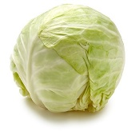
When life gives you cabbage, you make sauerkraut — and homemade sauerkraut is a world apart from the stuff that comes from the grocery store. Sauerkraut is made by a process called lacto-fermentation. It is made with Lactobacillus, a bacteria found in yogurt and many other cultured products that is beneficial to your digestive tract.
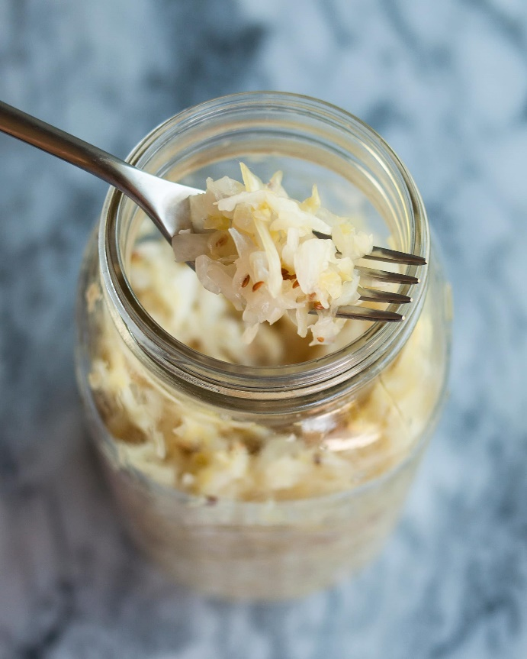
Ingredients:
1 medium head green cabbage (about 3 pounds)
1 1/2 tablespoons kosher salt
Mason jar (or old pasta jar) with lid

Directions
- Clean everything. Make sure your mason jar and hands are rinsed of all soap residue.
- Slice the cabbage: Discard the wilted, limp outer leaves of the cabbage. Cut the cabbage into very thin ribbons.
- Transfer the cabbage to a big mixing bowl and sprinkle the salt over top. Begin working the salt into the cabbage by massaging and squeezing the cabbage with your hands. Gradually the cabbage will become watery and limp — more like coleslaw than raw cabbage. This will take 5 to 10 minutes.
- Pack the cabbage into the jar. Every so often, tamp down the cabbage in the jar with your fist. Pour any liquid released by the cabbage while you were massaging it into the jar. Once all the cabbage is packed into the Mason jar, weigh the cabbage down with clean stones or marbles. Make sure the cabbage is underneath the liquid! Cover the mouth of the Mason jar with a cloth and secure it with a rubber band or twine.
- Press the cabbage every few hours: Over the next 24 hours, press down on the cabbage every so often with the jelly jar. As the cabbage releases its liquid, it will become more limp and compact and the liquid will rise over the top of the cabbage. Ferment the cabbage for 3 to 10 days: As it's fermenting, keep the sauerkraut away from direct sunlight and at a cool room temperature — ideally 65°F to 75°F. Check it daily and press it down if the cabbage is floating above the liquid.
- After 3 days — when the sauerkraut tastes good to you, remove the weight, screw on the cap, and refrigerate. You can also allow the sauerkraut to continue fermenting for 10 days or even longer. There's no hard-and-fast rule for when the sauerkraut is "done" — go by how it tastes. Enjoy!

